Name: Sreang Rathanak, Chhom Sophanith

Class: Evening

**Topic: Digital Image Watermarking**

1. **Introduction**

A **digital watermark** is a kind of marker covertly embedded in a noise-tolerant signal such as audio, video or image data. It is typically used to identify ownership of the copyright of such signal. "Watermarking" is the process of hiding digital information in a carrier signal; the hidden information should, but does not need to, contain a relation to the carrier signal.

In **Digital Image Watermarking** the watermark signal is embedded into a source image that is to be protected against abuses. Watermark can be a string of bits representing a text or owners name or an image such as a trademark symbol or logo.

Watermarking systems are classified based on the method used for watermarking and also on certain features as visibility and strength of the watermark in the embedded media. The application scenario for which the watermarking is used has a significant say over the choice of the method used. Watermarking systems that are currently in use can be classified as follows

• **Visible or Invisible**

This classification is based on the perceptibility of the hidden watermark in the host media. Visible Watermarking techniques provide means for overt assertion of ownership rights. Whereas, Invisible watermarks are imperceptible to human eyes and hence provides covert protection of rights.

**• Fragile or Robust**

Robust watermarks are able to withstand degradations or attacks on watermarked images. Fragile watermarking however is broken or lost when they are a subject to attacks. The application for which Fragile and Robust watermarking used differs. A robust watermark is often used for the cases where copyright or ownership rights are to be ascertained. Fragile watermarks break on modifications. Hence these methods are well suited for content authentication or tamper proofing. Another sub-category is semi-fragile watermarking. Semi-fragile watermarking is designed to break under any changes that exceed a threshold specified by the user. In other words, a semi-fragile watermarking scheme allows some amount of modifications upon the original content and breaks beyond a limit permitted by its owner

1. **Objective**

The Watermarking that we are going to implement is visible watermarking where we allow user to choose an original image and a watermark image. Then we are going to produce the watermarking image by merging those two images together and save it into a new image file.

1. **Visable watermarking algorithm**

Before apply watermarking algorithm to merge our images, we need to make sure the watermark image size is smaller than the original image. Therefore, we need to resize the watermark image into the right size where in our case the water mark image’s size 20% of the original image size. For resizing image, we use the nearest neightbor algorithm.

The watermarking algorithm for this application is:

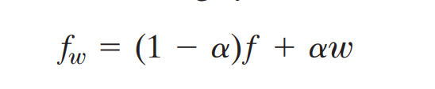However, we allpy watermark algorithm to those image directly, it will product black background on the area where watermark is applied.

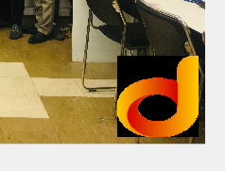

To solve this problem, we first crop the area of original image where watermark is going to apply. Then we apply the water mark of with watermark image with the croped image. Then we apply edited watermark image on our original image. And the result we will get as below.

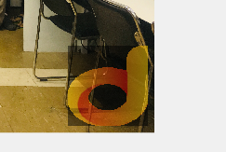

1. **Result**

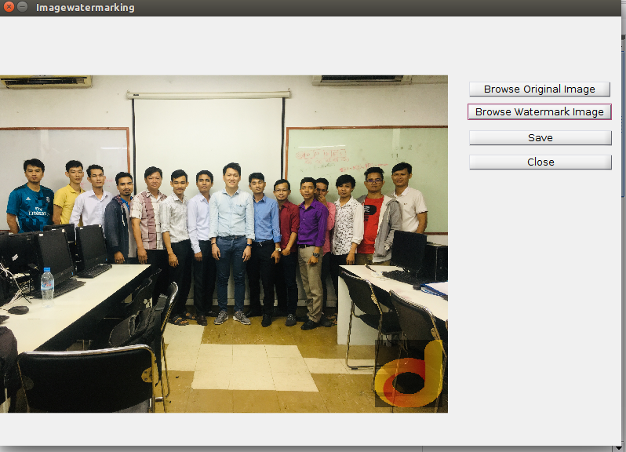

1. **Conclusion**

<https://www.researchgate.net/publication/272747716_Digital_Image_Watermarking_An_Overview>